SpringBoot projects
Contents
• UsersServiceSpringBoot 1
• spring-boot-testing-reddit-clone 5

- UsersServiceSpringBoot
IDE: IntelliJ IDEA

unit testing in SpringBoot Application
- Dependencies:
Spring Web, Spring Security (for authentication, to encrypt password), Spring Data JPA (H2 database)
ModelMapper (auto mapping), Spring Validation, mockito, junit, maven, Spring Boot 2.7.1, packaging jar.

Can start your project using Spring initializr: https://start.spring.io/
- Steps:
- Main application, @SpringBootApplication, UsersServiceSpringBootApplication.java
Run main(), start server Tomcat port 8888.
Its test is: UsersServiceSpringBootApplicationTest.java

Controller, HTTP endpoints, @RestController, UsersController.java

- Test with postman:
Post: http://localhost:8080/users
request:
{
"firstName":"Zarbio",
"lastName": "Ordoñez",
"email": "test@test.com",
"password": "12345678",
"repeatPassword": "12345678"
}

response:
{
"userId": "f5428a06-f80e-467e-a894-55d98bc7d5b5",
"firstName": "Zarbio",
"lastName": "Ordoñez",
"email": "test@test.com"
}

- Implement tests: Unit tests and Integration tests.

- Unit Test:
Test only one layer, mock the rest.

e.g.: for web service only the Web Layer

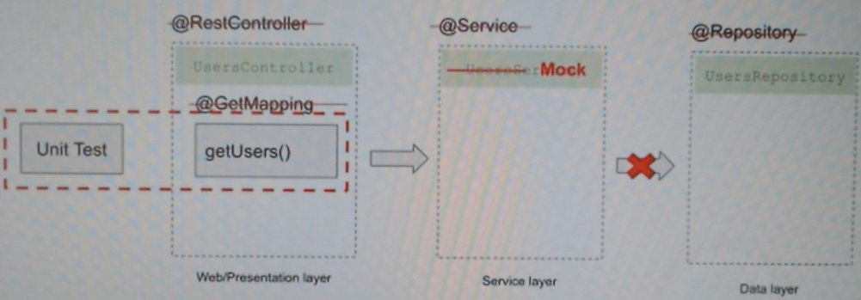

@Restontroller: methods, HTTP requests
@Service: business logic (sorting, filtering)
@Repository: data access objects for database.

In this project, test web layer, mock the rest layers.

Sprint Framework will create Sprint application context for web layer only.

Test REST Controllers: UsersControllersWebLayerTest.java: tests for UsersController.java

Unit Test for getUsers() method: involve mock Service, don’t include @Repository.

UsersControllerWebLayerTest.java
- Integration Test:
Involve all layers, no mocking any layer.

e.g.: Web Layer, Service Layer, Data Layer

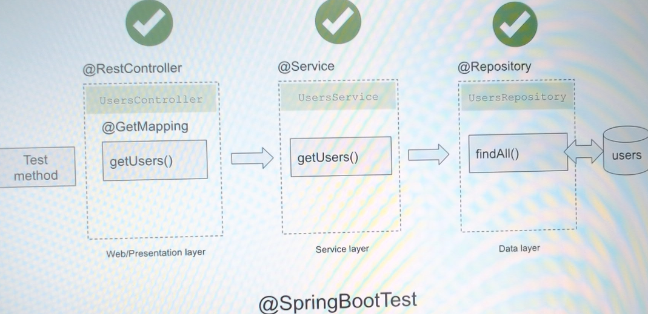

In this project, test all layers (Web Layer, Service Layer, Data Layer), UsersController.java, UsersService.java, UsersRepository.java

UsersControllerIntegrationTest.java. Integration Test

@SpringBootTest: create application context run similarly as a production but by default does not start a web server.
Can configure @SpringBootTest to load a real web environment with embedded server running on specific port number.

application.properties

Authentication and Authorization with JWT access token

JWT (JSON Web Token) is used in API authentication and authorization, mostly to retrieve a list of objects.
JWT access token in authorization header

methods to test:
post: createUser(), create user in in-memory database (h2)
get: getUsers(), get list of users

- Testing Data Layer only for an Entity (JPAN Entities):
Test Data Layer of Spring Boot Application

UserEntityIntegrationTest.java, UserEntity.java

Integration tests for data layer separately from other layers

JPA Entities

@DataJpaTest: Application Context with JPA-related components only.

By default, test method is Transactional and will rollback when completes.

By default, in-memory database is used.

com.appsdeveloperblog.tutorials.junit.io
UserEntity.java
UserRepository.java

UserEntityIntegrationTest.java

- Testing JPA Repository:
test code that was written by us.

not to write test methods to test query methods, because if the method is incorrect, then your application will fail to start up, optionally write test for the query methods with large names.

Write test for JPQL Query

JPQL (Java Persistence Query Language)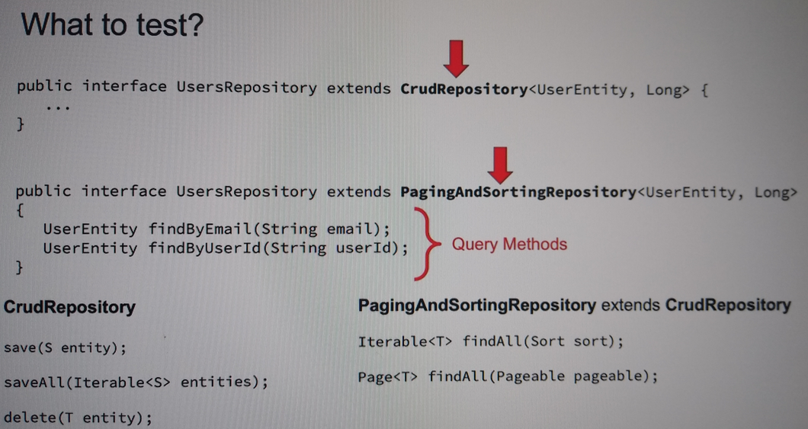

The query method name can be more complex:
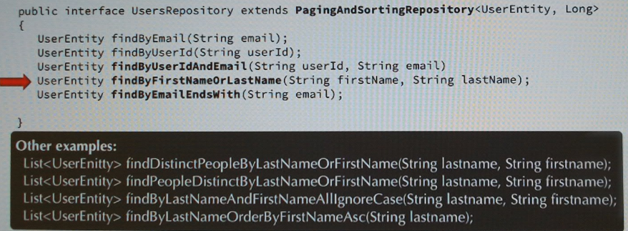

In that case, for complex names is useful use JPQL queries, so write tests for JPQL queries:
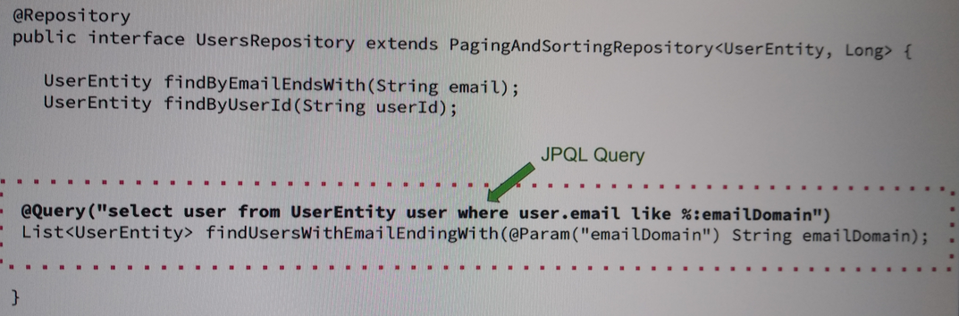

UsersRepositoryTest.java, UsersRepository.java

refs:
Testing Java with JUnit 5 & Mockito
https://tcsglobal.udemy.com/course/testing-java-code-with-junit-5-and-mockito/learn/lecture/31481676#overview
Section 10: Spring Boot - Testign REST Controllers

- spring-boot-testing-reddit-clone
Spring Boot Testing Tutorial - Crash Course
https://www.youtube.com/watch?v=aPoJPESMJBk
- Architecture
User -> Angular <-> Spring Boot -> MySQL

Controller Layer <-> Service Layer <-> Persistence Layer
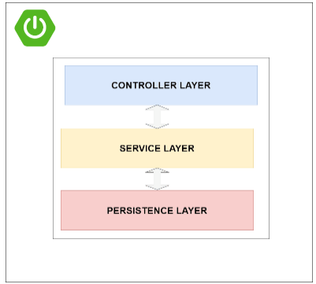
- Reddit Clone Application
Reddit clone with Spring boot and Angular
https://programmingtechie.com/2020/05/14/building-a-reddit-clone-with-spring-boot-and-angular/
See explication of development

- Backend:
Java 8, Spring Boot, Spring Security with JPA Authentication, Spring Data JPA with MySQL, Spring MVC, Token Based Authentication in the form of JSON Web Tokens (JWT).
repository: https://github.com/SaiUpadhyayula/spring-reddit-clone

- Frontend:
Angular 9, Bootstrap 4
repository: https://github.com/SaiUpadhyayula/angular-reddit-clone
- Tests
https://github.com/SaiUpadhyayula/spring-boot-testing-reddit-clone

JUnit 5
- Unit Testing using Junit 5 and Mockito: Unit Test for Service Layer
https://programmingtechie.com/2020/10/16/spring-boot-testing-tutorial-unit-testing-with-junit-5-and-mockito/

Unit Testing is a practice in the software development process, where you test the functionality of a component (e.g.: java class) in isolation, without depending on any external dependencies. We cannot use any Spring features.

A rule of thumb to remember when testing our code, is to make sure that the test we wrote actually fails when the behavior of the code changes, that is the main reason we are writing tests, to get the feedback immediately when we unintentionally changed the behavior of the method.

CommentController.java (Controller Layer, class) -> CommentService.java (Service Layer, class) -> CommentRepository.java (Persistence Layer, interface)

CommentService.java -> CommentServiceTest.java
PostService.java -> PostServiceTest.java

JUnit 5 built-in Assertions
AssertJ library (is more readable, use Fluent API)

- We can replace the assertions methods of JUnit 5 by the AssertJ library (is more readable):
assertThat(commentService.containsSwearWords("This is a comment")).isFalse();

assertThatThrownBy(() -> {
commentService.containsSwearWords("This is a shitty comment");
}).isInstanceOf(SpringRedditException.class)
.hasMessage("Comments contains unacceptable language");

- @Transactional(readOnly = true)
used in Spring Data JPA or Spring JDBC, simplifies transaction management in data access operations, ensuring consistency and atomicity of database operations.
- Integration Testing the DB Layer using Test Containers: Test for Persistence Layer
https://programmingtechie.com/2020/10/21/spring-boot-testing-tutorial-database-testing-with-test-containers/

Test Data Access Layer with Test Containers, test the interaction between Persistence Layer and Database

- Testing the Database layer using an embedded database:
Test using h2 in-memory database:

<dependency>
<groupId>com.h2database</groupId>
<artifactId>h2</artifactId>
<version>1.4.200</version>
<scope>test</scope>
</dependency>

Configuration: application-test.properties

PostRepository.java
PostRepositoryTestEmbedded.java
@ActiveProfiles("test") // get application-test.properties for h2 database

Test the database logic:
@Sql("classpath:test-data.sql")

- Testing Database Layer using TestContainers:
Here I use MySQL (like production database) test container instead of H2 in-memory database.

TestContainers: Java library for JUnit tests using Docker container.

Requeriments:
1. Install Docker Engine.
2. Add MySQL test container dependency in Java project. It allow to run MySql database inside a container:

<dependency>
<groupId>org.testcontainers</groupId>
<artifactId>mysql</artifactId>
<version>1.14.3</version>
<scope>test</scope>
</dependency>

MySQL database name is: spring-reddit-test-db

https://testcontainers.com/
https://java.testcontainers.org/test_framework_integration/manual_lifecycle_control/

BaseTest.java: MySQL test container
PostRepositoryTest.java
UserRepositoryTest.java
- Testing REST APIs using Spring MockMvc: Test for Controller Layer
https://programmingtechie.com/2020/10/23/spring-boot-testing-tutorial-testing-rest-apis-using-mockmvc/

@WebMvcTest: create the Spring Context with only beans which are related to the Spring MVC components like @Controller, @RestController, @AutoconfigureWebMvc, etc.

test for web/presentation layer (@WebMvcTest)

PostController.java, PostControllerTest.java
PostService.java, getAllPosts()

